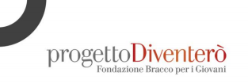
“Research according to Francesca: the rigour of a detective and an empathic method”
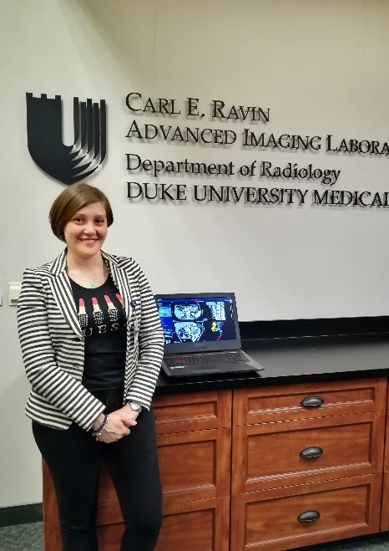
Francesca Rigiroli, MD., born in 1988, is a radiologist who won a research fellowship promoted by the Bracco Foundation at the Duke University in Durham, North Carolina, one of the most prestigious universities in the United States.
During this experience she carried out a scientific project on radiomics applied to abdominal images for staging and prognosis of tumours.

The years of specialisation: introduction to practice and communication with patients
Francesca was full of curiosity since she was a child, it was always important for her to understand how the things around her worked, be they objects or phenomena (her favourite television program was Superquark).
Being able to spot a trace is often the key to finding a pathology or meeting a need, just as knowing how to communicate with patients becomes crucial for a radiologist’s investigations. Among the experiences Francesca had as an intern while specialising in several Milanese hospitals and centres, including the San Carlo and the Policlinico, she cites her time at the CDI – Centro Diagnostico Italiano where she carried out research into patient satisfaction. As we interviewed them, Francesca realised that they are curious and often aware. “Unlike some of my colleagues, I consider a dialogue with patients very stimulating, it forces me to stay continually up-to-date.”
Experience in the United States: shared ideas, practising alone
in 2018 Francesca won a Bracco Foundation scholarship that allowed her to fly to the United States to carry out a scientific radiological project at Duke University (North Carolina). The impact with American reality was not easy, the most difficult aspect the young radiologist remembers was the bureaucratic complexity and rigid rules she met within the initial phase of her stay. Then the level of scientific research was extremely high and the system had an efficiency that made it open to change.
Here Francesca began, under the guidance of her mentor Professor Daniele Marin, MD., a scientific project that was a challenge from the outset. The project, “Radiomics applied on staging and clinical outcome of Pancreas Ductal Adenocarcinoma”, involved one of the most deadly oncological pathologies in which surgical treatment is still the only hope for a definitive cure. The method experimented on by Francesco with the involvement of a team of other specialists (surgeons, physicists, oncologists) involve the use of Radiomics, a leading-edge technique in diagnostics that makes it possible to derive from images a huge amount of numerical data processed with machine learning techniques. With this method it is possible to make predictions on the state of the artery, to see whether the tumour has infiltrated it or not. After the initial phases and that of data collection, in April 2019 Francesca obtained the preliminary results, which were positive and could thus become a consolidated practice in the coming years.

